ATPHY 2018
Electromagnetism Investigation | 3.0%
Part (2) Quiz: Solutions

Student name:

Questions:
1. State what the betatron is mainly used for. [3]
It accelerates electrons to high speeds. [1]
It is used in producing x rays and [1]
for medical purposes such as cancer therapy. [1]
2. What is the value of the speed mentioned as v = 0.999987c where c is the speed of light? Give your answer to 5 significant figures. [2]
v = 0.99987 x 3 x 10⁸ [1]
= 2.9996 x 10⁸ m/s [1]
3. Show that 1 Volt = 1 Weber / second. [3]
1 Wb / s = $Φ$ /t [1]
By Faraday’s Law, induced emf $ε=-N\frac{∆Φ}{∆t}$ [1]
For a change of 1 Wb / s, an emf of 1 Volt is induced. [1]

4. Explain why an electron-volt can be considered to be a unit of energy. [2]
1eV = 1 x charge of an electron x voltage applied to electron. [1]
As W = qV, 1 eV is actually a measure of work done on the electron or change in energy. [1]

5. Can an induced current ever establish a magnetic field B that is in the same direction as the magnetic field inducing the current? Justify your answer. [3]
No, it cannot. [1]
It would violate the law of conservation of energy. [1]
If that were true, the magnetic field would add up to get stronger. Energy is being created and not being converted to other forms. [1]

6. Suggest a suitable material for the magnetic core of the betatron. Justify your answer. [2]
It could be made of a soft iron core. [1]
The iron core concentrates the magnetic field. OR
It is easily magnetized and demagnetize and is responsive to the alternating current. [1]
7. In the betatron, the magnetic core is made of laminated sheets rather than of solid material. Explain why this is so. [3]
Laminated sheets are designed to reduce the eddy currents [1]
that result from Lenz’s law where a current is induced that opposes the change in magnetic flux [1]
If solid material was used, the heat loss due to the eddy currents would be very large. [1]

8a) Explain how the magnetic field guides the electrons in a circular path. [2]
The magnetic field acts on the moving electrons and produces the Lorentz electromagnetic force. [1]
This force acts perpendicular to the motion of the electrons. [1]
This results in giving the electrons a circular path.
b) Explain how the changing magnetic field produces an induced electric field in the electron chamber. [2]
By Faraday’s Law, the induced emf is proportional to the rate of change of magnetic flux linked. [1]
The changing magnetic flux acts on the moving electron and produces an induced emf in the chamber. [1]
9. You want to increase the radius of the circular path by imposing an additional magnetic flux $∆Φ$. Should the lines of B associated with this increase be in the same direction as the lines shown in the figure (Fig. 1 of Research handout) or in the opposite direction?
Explain your answer. [3]
They should be in the same direction to have added flux. [1]
$Φ$ = B.A. Flux is given by the product of B and the area enclosed by the magnetic field lines. [1]
The sum of the two B fields in the same direction gives greater B and hence an additional flux B.A. [1]

10. State the direction of the force acting on the electron on the right hand side of the betatron. [1]
Toward centre of orbit [1]
Explain how you arrived at your answer. [2]
Using the right hand palm rule, the fingers point in the direction of B, the thumb points out of the page (in direction opposite to electron flow), [1]
the palm gives the direction of the electromagnetic force. [1]

11. In a 100-MeV betatron, the orbit radius R is 84 cm. Assume that the orbit is circular. The magnetic field in the region enclosed by the orbit rises periodically (60 times per second) from zero to a maximum value $B_{max}=0.8\text{T}$ in an accelerating interval of one-fourth of a period, or 4.2 ms.
(a) What is the maximum magnetic flux, $Φ_{max}$ , attained during the accelerating interval? [2]
$Φ_{max}=\left(B_{max}\right)\left(πR^{2}\right)$ [1]
$=\left(0.80T\right)\left(π\right){\left(0.84m\right)}^{2}=1.77 Wb$ [1]
(b) Using the answer to (a), determine the rate of change of flux (induced emf) during the time interval of acceleration. [2]
$\frac{∆Φ}{∆t}=\frac{1.77 \text{Wb}}{4.2×{10}^{-3}}$ [1]
$=421 \text{Wb/s or }$V [1]

(c) Given that 1 eV (electron volt) is the energy gained by an electron moving across a potential difference of 1V, show that the number of revolutions required for an electron to reach its final energy of 100 MeV is approximately 238,000 revolutions. [2]
Number of revolutions = 100 x 10⁶ / 421 [1]
= about 238,000 revolutions [1]

(d) Find the total distance travelled by an electron along its circular path before reaching its full energy of 100 MeV. [2]
Total distance = 238,000 x 2 x π x 0.84 [1]
= 1250 km [1]
(e) Calculate the average speed of the electron as it travels the total distance needed to reach 100 MeV during the acceleration time interval of 4.2 ms. [2]
Average speed = distance / time = 1250 x 10³ / 4.2 x 10⁻³ [1]
= $2.86×{10}^{8}\text{m/s}$ [1]$v=\frac{1250×{10}^{3}}{4.2×{10}^{-3}}=2.98×{10}^{8}\text{m/s}$

12. The varying magnetic field in the betatron can be represented by the graph below:
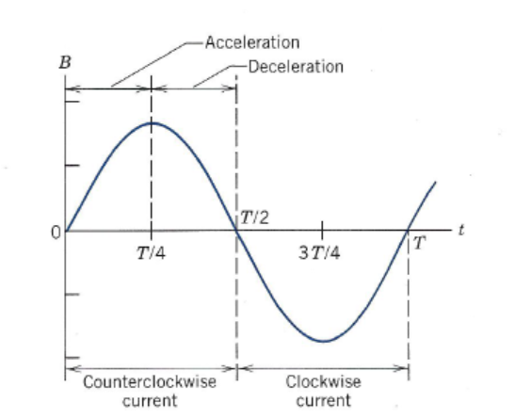

On the axis below, sketch the shape of a corresponding graph of induced emf versus time as the B field varies. [3]

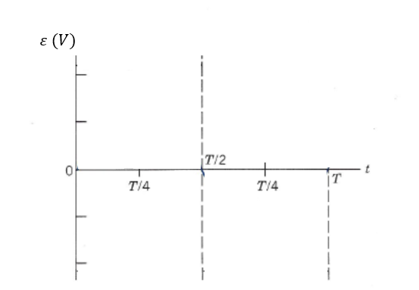
Periodic sinusoidal shape [1]
Maximums at right times [1]
Minimums at right times [1]
13. Once accelerated, the electrons are directed out of the doughnut chamber, or inwards, towards a metal target to produce x-rays.
X-rays are a form of electromagnetic radiation. They have a wavelength ranging from 0.01 to 10 nm.
(a) What are the highest and lowest frequencies of x-rays? [3]
$v=fλ$ [1]
$v=3.00×{10}^{8}\text{m/s}$
When wavelength = 0.01 nm; $f=\frac{v}{λ}$ = 3.0 x 10⁸/0.01 x 10⁻⁹ = 3.0 x 10¹⁹ Hz [1]
When wavelength = 10 nm; $f=\frac{v}{λ}$ = 3.0 x 10⁸/10 x 10⁻⁹ = 3.0 x 10¹⁶ Hz [1]
14. The betatron can be thought of as a transformer. Transformers have a primary and secondary coil. The magnetic field is changed by passing alternating current to the primary coil. A current is induced in the secondary coil by Faraday’s Law. [2]
(a) State which part of the betatron behaves like the primary coil of a transformer.
The primary coil is the coils C. [1]
(b) State which part of the betatron behaves like the secondary coil of a transformer.
The secondary coil is the ring of electrons in the tube. [1]

15. Referring to the values given in Question 11, suggest some strengths of the design of a betatron as a particle accelerator. [2]
It can be of a small size. The radius in our example is 84 cm. [1]
The value of the B field applied of 0.8T is not too large compared to other particle accelerators. [1]
16. What are some ways that you can increase the energy of radiation emitted by the betatron? [2]
We can increase the strength of the alternating current. [1]
We can increase the frequency of injection of electrons. [1]

